Topic:

“Interacts professionally and helpfully with other teams.”

Evidence:

My Comment on Sarah's Post

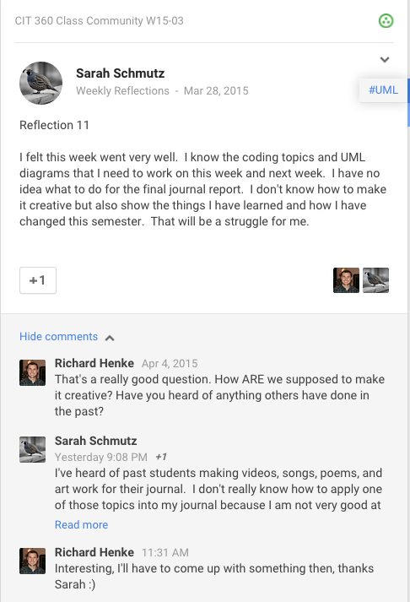

My Comment to Trevor

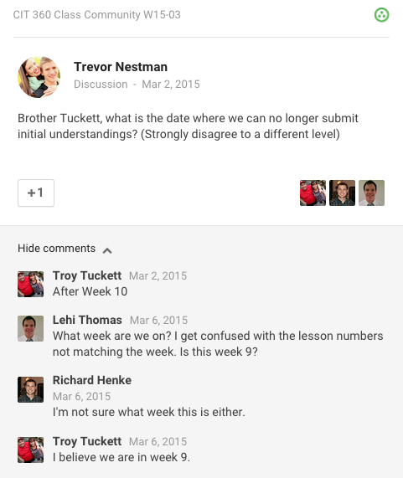

My Other Comment to Trevor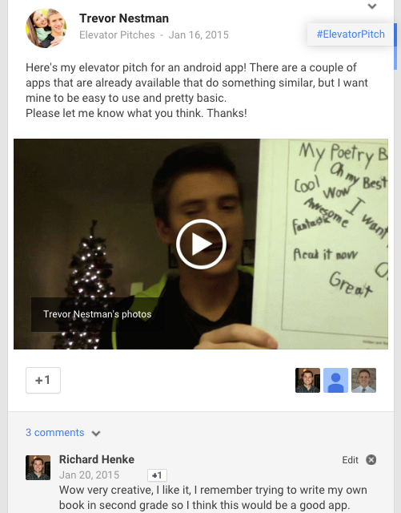

My Comment to Clayton Anderson

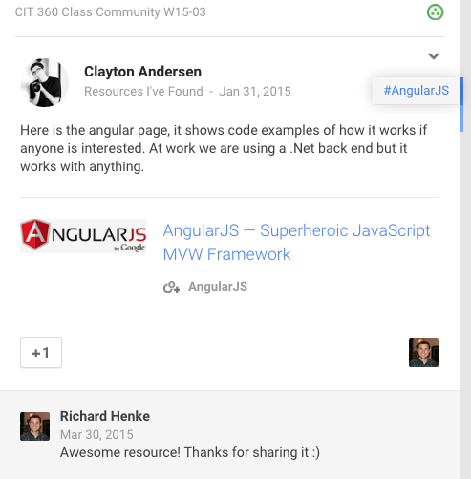

My Post to Help Others See Their Comments



My Comment to Help Brooke

